**COMSATS University Islamabad,   
Abbottabad Campus**

**Project Proposal   
(SCOPE DOCUMENT)**

**for**

**<Saving Bot>**  
Version 1.0

***By***

**BASIT IQBAL CIIT/FA21-BSE-050/ATD**

**FATIMA AFTAB CIIT/FA21-BSE-080/ATD**

**WALEED RASHID CIIT/FA21-BSE-162/ATD**

***Supervisor*Syed Shahab Zarin**

***Bachelor of Science in Computer Science (2021-2024)***

|  |  |  |
| --- | --- | --- |
| **No.** | **Comment** | **Action** |
|  |  |  |
|  |  |  |
|  |  |  |
|  |  |  |
|  |  |  |
|  |  |  |

**SCOPE DOCUMENT REVSION HISTORY**

**Supervisor Signature**

**Date:**

**Table of Contents**

Table of Contents

Abstract 5

1. Introduction 6

2. Problem Statement 7

3. Problem Solution for Proposed System 7

3.1. Object Detection: 7

3.2. Web Scraping for Price Information: 7

3.3. Seamless User Interface: 7

4. Related System Analysis/Literature Review 7

4.1. Existing Similar Systems: 7

5. Advantages/Benefits of Proposed System 8

5.1. Image recognition: 9

5.2. Wider Search Scope: 9

5.3. Flexibility: 9

6. Scope 10

6.1. Functionality: 10

6.2. Technical Considerations: 10

6.3. Exclusions: 10

6.4. Platform: 10

6.5. Future Development: 11

7. System Limitations/Constraints 11

7.1. Limitations 11

7.2. Constraints 11

8. Software Process Methodology 11

8.1. Flexibility: 12

8.2. Reduced Risk: 12

8.3. Prioritization: 12

9. Tools and Technologies 13

10. Project Stakeholders and Roles 13

11. Data Gathering Approach 13

12. Concepts 14

13. Gantt chart: 15

13.1. Gantt chart using MS Project 15

13.2. Gantt chart using MS Excel 16

14. Network Diagram 17

14.1. Activity 17

14.2. Activity on Node 17

15. Work Break down Structure 18

16. Cost Estimation of project Using COCOMO II Model 19

16.1. Basic model: 19

16.2. Intermediate model: 21

16.3. Detailed Model: 25

17. References 27

18. Plagiarism Report 27

Table 1: Related System Analysis with proposed project solution 8

Table 2: Tools and Technologies for Proposed Project 12

Table 3: Project Stakeholders for Proposed Project 12

Table 4: Project EAF 22

Figure 1: Gantt chart using MS Project 14

Figure 2: Gantt chart using MS Excel 15

Figure 3: Activity on arrow diagram 16

Figure 4: Activity on Node 16

Figure 5: Work break down Structure 17

Figure 6: Constant Values According to type of Project. 18

**Project Category: (**Select all the major domains of proposed project**)**

* **A-**Mobile Application/Information System **B-**Web Application/Mobile Application **C-** Problem Solving and Artificial Intelligence ** D-**Simulation and Modeling ** E-** Smartphone Application ** F-** Smartphone Game ** G-** Networks ** H-** Image Processing****Other (specify category) ______________________

## Abstract

The endeavor at hand is the development of an AI-powered Shopping Optimizing APP, (i.e. Saving Bot) designed to revolutionize the shopping experience. Targeting the individuals seeking the best deals prices on fashion items. This application will use advanced image recognition algorithms to identify the items uploaded by users. The algorithm that we will use is VGG-16 which is an image recognition model that is used to identify the objects. Hence this algorithm will swiftly identify the attributes of items like color, patterns, and style facilitating precise searches across multiple online stores.

Upon user submission, the application systematically searches various online platforms extracting information from variety of retailers. Using its skills in computer programming and data analysis, the app collects a lot of price options. Users then see a list of stores with prices and links to buy things easily.

The project combines advanced AI-Technology with user-friendly interface to streamline shopping experience for our target users. By giving users instant access to the best deals, the app changes how easy and valuable shopping experience can be.

## Introduction

In the current digital era, technology continues to transform the way we interact with the world, including how we shop. One of the most important advancements in this domain is the integration of artificial intelligence (AI) and machine learning (ML) into everyday applications. AI technologies, particularly in the fields of image recognition and data analysis, are revolutionizing various industries by enabling more intelligent and efficient processes.

**Image recognition** is a branch of AI (artificial intelligence) that encompasses the training algorithms to identify and classify objects within images. These algorithms, such as the widely used VGG-16 model, can analyses visual data to detect specific features like colour, shape, and patterns. This technology has many applications, from facial recognition systems to automated quality control in manufacturing and industry.

Another crucial and vital technology is **web scraping**, a technique used to extract data from websites. By automating the process of gathering information, web scraping allows for the efficient and convenient collection of large datasets from multiple sources. This data can then be analysed and used to provide valuable insights, such as comparing prices across different online retailers, which can also be used to make predictions.

Combining these advanced technologies creates powerful tools that can significantly enhance user experiences in various domains, including online shopping. Online shopping has become a staple of modern life, offering convenience and a vast array of choices. However, finding the best deals can be time-consuming and frustrating due to the overwhelming number of options and the difficulty in comparing prices across different websites.

To address these challenges, we propose the development of the **Saving Bot**, an AI-powered shopping optimization app designed to streamline the online shopping experience. The Saving Bot leverages the capabilities of image recognition and web scraping to offer a unique and efficient solution for finding the best deals on fashion items.

Users can simply upload a picture of the clothing item they are interested in, and the app's sophisticated image recognition algorithm, based on the VGG-16 model, accurately identifies the item's attributes. The app then utilizes advanced web scraping techniques to gather real-time pricing information from numerous online retailers. By compiling and comparing these prices, the Saving Bot presents users with a comprehensive list of options, ensuring they can easily find the best deals available.

This project not only aims to make online shopping more accessible and affordable but also promises to enhance user satisfaction by providing a seamless and intuitive interface. By integrating cutting-edge AI technology with practical application, the Saving Bot stands to revolutionize the way users shop for fashion items online, offering a smarter and more efficient alternative to traditional methods.

## Problem Statement

Online Shopping is a Hellish experience! When you find the perfect outfit, but only in size they haven’t invented it yet. Shoppers are frustrated with the unlimited number of stores, hassle to find the best price, and have difficulty comparing prices and outfits and sizes across different products. Now in this continuously evolving word what we need is a user-friendly app that uses curing edge technology to automate this process and do the work of comparison for us.

## Problem Solution for Proposed System

The Saving Bot tackles the challenges of online shopping with a multi-functional approach, featuring these key elements:

* 1. Object Detection: The app uses VGG-16 for the detection of clothes from the images uploaded by the user to accurately identify the style, color, and pattern of the clothes, enabling precise searches and comparisons.
  2. Web Scraping for Price Information: Advanced web scraping techniques are used to gather real time pricing information from numerous online retailers, ensuring that the user will have access to the most up-to-date data.
  3. Seamless User Interface: A user-friendly interface is designed to provide an intuitive and hassle-free shopping experience, allowing users to navigate the app effortlessly and make informed choices.

## Related System Analysis/Literature Review

### Existing Similar Systems:

* + 1. General Price Comparison Websites: Websites like Google shopping and Shopzilla allow users to search for a specific item and compare prices across various online stores. However, these websites require users to know the item's name or brand beforehand. They lack the image recognition capability of your proposed application.
    2. Browser Extensions: Browser extensions like Honey or Invisible Hand automatically search for coupons and price comparisons while users shop online. However, they are limited to the store the user is currently browsing and cannot search for an item across multiple stores based on an image.
    3. Barcode Scanners**:** Mobile apps like Shop Savvy or Amazon app allow users to scan barcodes of physical products to find online prices. They require the product to have a barcode and cannot identify items based solely on an image.

|  |  |  |  |  |
| --- | --- | --- | --- | --- |
| S.NO | Similar Systems | Similar Functionality | Limitation | Proposed Project Solution |
| 1 | Google shopping | General Price Comparison Websites | Can’t do image recognition. | Uses image recognition to identify items from an image uploaded. |
| 2 | Honey | Browser Extensions | Limited to Current Online Store. | Searches for Price Comparison on various stores based on image uploaded. |
| 3 | Shop Savvy | Barcode Scanners | Require physical products with barcode. | Identify item from an image eliminating the need for a barcode. |
| 4 | Invisible Hand | Browser Extensions | Limited to Current Online Store. | Searches for Price Comparison on various stores based on image uploaded. |
| 5 | Shopzilla | General Price Comparison Websites | Can’t do image recognition. | Uses image recognition to identify items from an image uploaded. |
| 6 | Amazon | Barcode Scanners | Require physical products with barcode. | Identify item from an image eliminating the need for a barcode. |

Table 1: Related System Analysis with proposed project solution

## Advantages/Benefits of Proposed System

Here are the advantages and benefits of the Saving Bot:

* 1. Image recognition: User can find the best price of an item simply by uploading and image or picture eliminating the need for manual searching.
  2. Wider Search Scope: The application searches across multiple online stores, offering a broader price comparison.
  3. Flexibility: It can identify the item without a barcode, making it applicable to wider range of items.

## Scope

### Functionality:

* **Item Identification:**
  + **Scope:** The application will focus on identifying clothing and fashion items in user-uploaded images.
  + **Accuracy:** The application will strive for high accuracy, aiming to identify similar items with slight variations in color or pattern.
* **Price Comparison:**
  + **Number of Stores:** The application will initially search for price comparisons across 5-10 major online clothing retailers.
  + **Price Update Frequency:** The application will update prices daily to ensure users have access to current deals.
* **Additional Features (Optional - for future development):**
  + Users can filter search results by brand, size, or color.
  + The application can suggest similar items based on the uploaded image and user preferences.
  + Integration with user reviews from trusted sources can be considered.

### Technical Considerations:

* **Image Recognition Model:**
  + The application will leverage a pre-trained image recognition model like VGG-16, fine-tuned on a relevant fashion image dataset (e.g., Kaggle Fashion Dataset).
* **Data Scraping:**
  + The application will ethically scrape price data from online stores, respecting their terms of service.
  + The system will be designed to handle data from multiple stores efficiently.

### Exclusions:

* The application will not include features like barcode scanning or in-app purchasing capabilities (users will be directed to retailer websites for purchases).
* Initially, the application will focus on English language support.

### Platform:

* The application will be developed as a cross-platform mobile app (iOS and Android) for wider user accessibility.

### Future Development:

* Based on user feedback and market demands, the scope can be expanded to include additional product categories, a wider range of stores, and more advanced features.

## System Limitations/Constraints

Here are some limitations and constraints of the Saving Bot:

* 1. Limitations:
* **Image Recognition Accuracy:**
  + VGG-16, while powerful, might not perfectly capture subtle variations in clothing items (like slight differences in fabric texture or embellishments). This could lead to inaccurate price comparisons for similar but not identical items.
* **Data Scraping Challenges:**
  + Websites may change their layout or data structure frequently, requiring the app to adapt its scraping techniques to maintain functionality.
  + Retailers might implement anti-scraping measures, making it difficult for the app to access price data reliably.
* **Limited Scope (Initial Version):**
  + Focusing on clothing initially limits the app's usability for other product categories.
  + Including only a few stores restricts users' access to the broadest range of deals.
  1. Constraints:
* **Computational Resources:**
  + Running image recognition models and scraping data requires processing power. This may limit the app's scalability to a large user base or restrict the number of stores it can search simultaneously.
* **Real-time Price Updates:**
  + Constantly checking prices across multiple stores can be resource intensive. Striking a balance between update frequency and efficient data usage is crucial.
* **Ethical Considerations:**
  + Data scraping must comply with website terms of service and avoid overloading their servers.

## Software Process Methodology

Agile development is ideal for the Saving Bot Mobile Application for several reasons:

* 1. Flexibility: As user needs or senior technology adoption evolves, agile development allows for incorporating new features or functionalities efficiently.
  2. Reduced Risk: By delivering features in small increments, agile development minimizes the risk of investing heavily in features that seniors may not find useful.
  3. Prioritization: Agile prioritizes the most impactful features first, ensuring the core functionalities that enhance well-being are delivered quickly.

## Tools and Technologies

We will be using following tools and technologies for building this project.

Example:

|  |  |  |  |
| --- | --- | --- | --- |
| Tools  And  Technologies | Tools | Version | Rationale |
| MS Visual Studio | 1.82 | IDE |
| Mongo DB | 2015 | DBMS |
| MS Project | CSC 6 | Management |
| MS Word | 2015 | Documentation |
| MS Power Point | 2015 | Presentation |
| Star UML | 2.0.5 | Mockups Creation |
| **Technology** | **Version** | **Rationale** |
| React Native | 0.72 | Framework |
| Express JS | 4.19.1 | Framework |
| Node JS | 21.0.0 | Run time environment |
| Java Script | ES 13 | Scripting Language |

Table 2: Tools and Technologies for Proposed Project

## Project Stakeholders and Roles

Write down the project stakeholders and their roles.

|  |  |
| --- | --- |
| **Project Sponsor** | COMSATS University, Islamabad Committee |
| **Stakeholder** | Mention your stake holders with their roles and responsibilities.  Default option will be:   * BASIT IQBAL, Fatima Aftab, Waleed Rashid * Project Supervisor Name: Mr Syed Shahab Zarin * Final Year Project Committee: Evaluation of project |

Table 3: Project Stakeholders for Proposed Project

## Data Gathering Approach

The data gathering approach for this project will include:

1. Using Kaggle data set.
2. Doing web scraping.

## Concepts

Concepts to be learned during this project include:

1. Object Detection techniques.
2. Using Kaggle Data set to Train Model (AI).
3. Web Scrapping
4. User Authentication and Authorization
5. Database design and management
6. Responsive Mobile App design

## Gantt chart:

### Gantt chart using MS Project

Figure 1: Gantt chart using MS Project

### Gantt chart using MS Excel

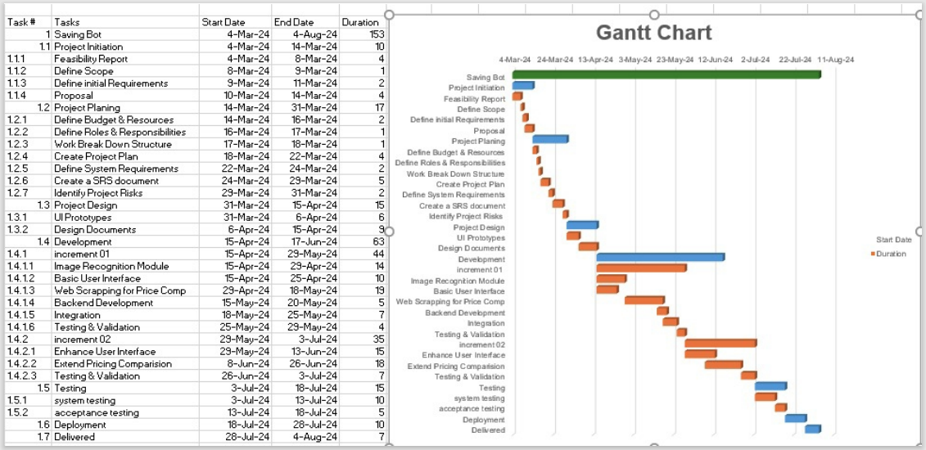

Figure 2: Gantt chart using MS Excel

## Network Diagram

* 1. 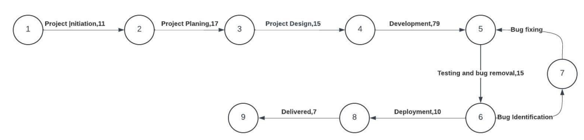Activity on Arrow

Figure 3: Activity on arrow diagram

### Activity on Node

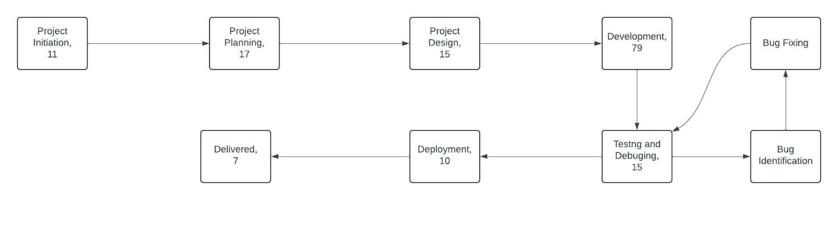

Figure 4: Activity on Node

## Work Break down Structure

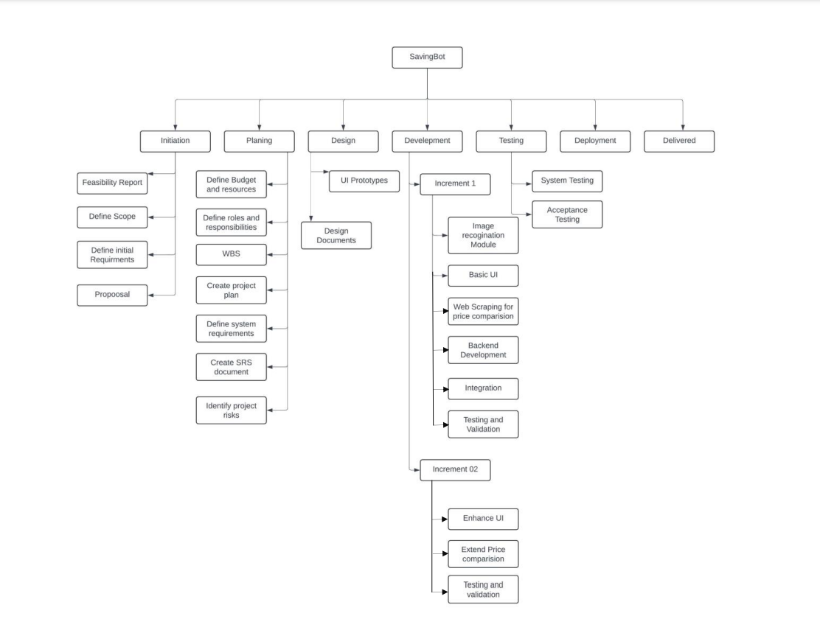

Figure 5: Work break down Structure

## Cost Estimation of project Using COCOMO II Model

**Total Line of Code:**

Total line of Code = 200KLOC

**Type of Project:**

As there are 200KLOC so it falls under the category of “semidetached”.

### Basic model:

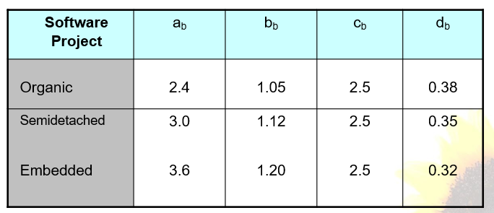According to the type of project we will pick the value of a, b, c, d from the following table.

Figure 6: Constant Values According to type of Project.

According to the table a=3.0, b=1.12, c=2.5, d=0.35.

Now we start the calculation.

#### Effort:

E= 3.0 (

E= 3.0×545.01

E= 1133.12 Person-Months

#### Development Time

D= 2.5

D=2.5×11.72

D=29.30 Months

#### Staff Size

SS=

SS= 38.67 People

#### Productivity

P=

P= 0.1765

### Intermediate model:

Now we will find the factors form the following table: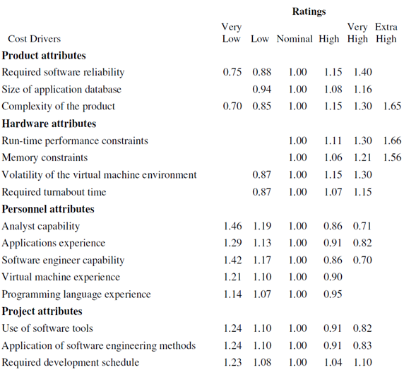

#### EAF according to Project

|  |  |  |  |  |
| --- | --- | --- | --- | --- |
| S. No | Attribute | Level | Reason of selecting level | Value from table |
| 1 | Required software reliability extent | High | Financial data (price comparisons) is involved, so minimal errors and crashes are crucial. | 1.15 |
| 2 | Size of the application database | Low | As it would store only the user info and some basic info related to the items | 0.94 |
| 3 | The complexity of the product | High | As first it would detect the item and then it will web scrape the items related to its which are available then it will compare the prices and at last it will show the items. | 1.15 |
| 4 | Run-time performance constraints | Very High | As the bot is using third part VGG-16 model to detect the item so it might take some time then it must scrape the websites for better results so it will take time | 1.30 |
| 5 | Memory constraints | Low | As the app wouldn’t store that much info | 1.00 |
| 6 | Required turnabout time | Normal | Instant responses aren't crucial. Users likely expect a few seconds for search results. | 1.00 |
| 7 | Analyst capability | Normal | As the analyst will have to understand the fashion trends, which keep on changing | 1.00 |
| 8 | Programming language experience | Normal | As we would be using VGG-16 which is per-built but we need a good experience in coding to do web-scraping and for front and backend development. | 1.00 |

Table 4: Project EAF

#### Effort Adjustment Factor

EAF = ∏ (factors)

EAF = 1.62

#### Effort:

E= 3.0 ( * 1.62

E= 3.0×545.01 × 1.62

E= 1835.12 Person-Months

#### Development Time

D= 2.5

D=2.5×11.72

D= 29.30 Months

D=29.30 Months

#### Staff Size

SS =

SS= 62.63 Persons

#### Productivity

P=

P= 0.109 KLOC/Person Months

### Detailed Model:

To provide a detailed COCOMO estimation for the project with the identified major components, we'll allocate the total effort calculated earlier (1835.12 Person-Months) across these phases. Here’s how we can break it down:

#### Major Phases

1. Responsive Mobile App design
2. Database design and management
3. Web Scraping
4. User Authentication and Authorization
5. Object Detection by VGG-16

#### Distribution of Effort

We'll assume a reasonable distribution of effort across these phases. This distribution will depend on the complexity and relative effort each component typically requires. A possible distribution could be as follows:

1. Responsive Mobile App design: 25%
2. Database design and management: 20%
3. Web Scraping: 15%
4. User Authentication and Authorization: 20%
5. Object Detection by VGG-16: 20%

#### Effort for each Phase

##### *Responsive Mobile App design:*

E= 1835.12×0.25

E=458.78Person-Months

##### *Database design and management:*

E=1835.12×0.20

E=367.02 Person-Months

##### *Web Scraping:*

E=1835.12×0.15

E=275.27 Person-Months

##### *User Authentication and Authorization:*

E=1835.12×0.20

E=367.02 Person-Months

##### *Object Detection by VGG-16:*

E=1835.12×0.20

E=367.02 Person-Months

#### Development Time for each Phase

To calculate the development time for each component, we will use the formula:

Where, 𝑐=2.5 and 𝑑=0.35

Let's calculate the development time for each component.

##### *Responsive Mobile App design:*

𝐷=2.5×

D=7.85 Months

##### *Database design and management:*

𝐷=2.5×

D=7.17 Months

##### *Web Scraping:*

𝐷=2.5×

D=6.26 Months

##### *User Authentication and Authorization:*

𝐷=2.5×

D=7.17 Months

##### *Object Detection by VGG-16:*

𝐷=2.5×

D=7.17 Months

## References

<https://www.kaggle.com/datasets/zalando-research/fashionmnist>

<https://www.shopzilla.com/>

<https://www.google.com/shopping?hl=en>

## Plagiarism Report

Attach the Plagiarism report of your project scope document from library staff of Turnitin tool:

Sir please add here as we don’t have Turnitin instructor account.